Install the User Client on Ubuntu Linux
You can deploy the PaperCut NG/MF User ClientThe User Client tool is an add-on that resides on a user's desktop. It allows users to view their current account balance via a popup window, provides users with the opportunity to confirm what they are about to print, allows users to select shared accounts via a popup, if administrators have granted access to this feature, and displays system messages, such as the "low credit" warning message or print policy popups. software on Linux and other Unix based operating systems using the following installation procedure.
To be able to do the installation change to be root (administrator).
# sudo su –
The command below is only used when connected to the Linux using ssh.
# xauth merge /home/<user>/.Xauthority

Step 1 – Set up printing

Download the ppd file:
# cd /tmp; wget -O Ricoh-IM_C5500_PS.ppd "https://www.openprinting.org/ppd-o-matic.php?driver=Postscript-Ricoh&printer=Ricoh-IM_C5500&show=0"
# cp Ricoh-IM_C5500_PS.ppd /etc/cups/ppd
# sudo apt-get update
# sudo apt-get upgrade

Step 2 – Preparations
# service cups stop
# apt-get install hplip smbclient
# mkdir /var/spool/cups/tmp/.hplip
# chown lp:lp /var/spool/cups/tmp/.hplip
# service cups start

Step 3 - Copy (or mount) the PaperCut NG/MF User Client files
Similar to the Windows version of the client software, the Linux/Unix Java version is installed in the ~/client directory on the server. Copy or make available to the Linux/Unix workstation, all files in this directory. Common methods include:
- Copying the files from the server using file transfer programs such as FTP or scp.
- If the server is Windows based, connecting using mount.cifs:
- # mount -t cifs -o user=<user> //meb-print01.meb.ki.se/PCClient/linux /mnt
- # mkdir –p /usr/local/papercut/client/
- # cp –rp /mnt/* /usr/local/papercut/client/
- # umount /mnt

Step 4 – Install the Follow Me Client

Start the command “system-config-printer”

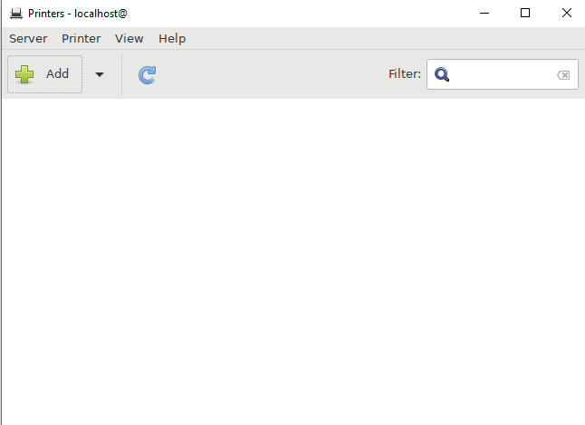

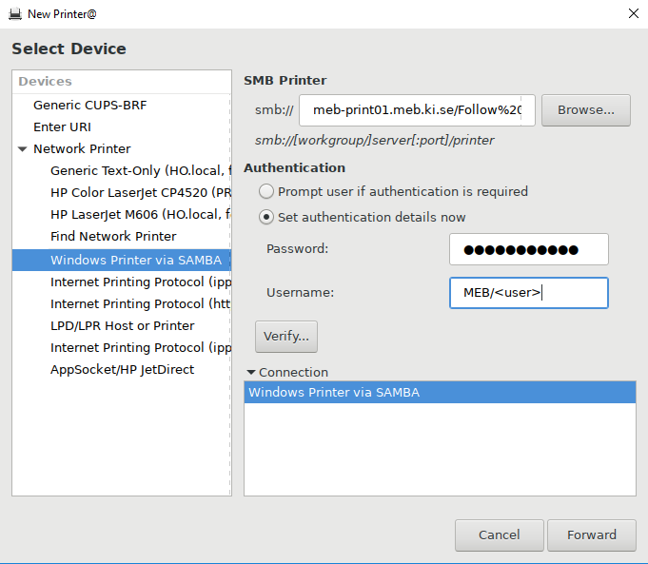

The url should be “smb://meb-print01.meb.ki.se/Follow%20Me%20Client”

sm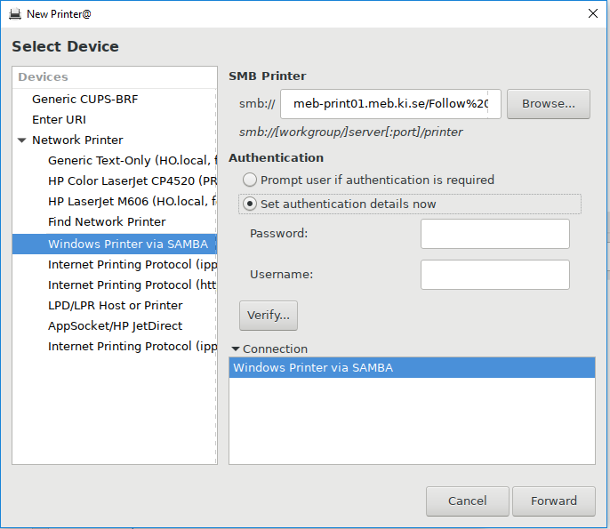

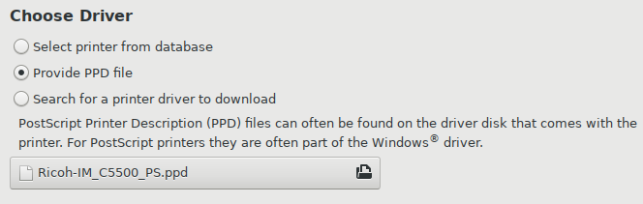

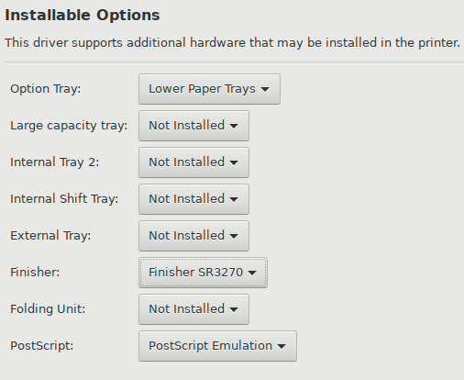

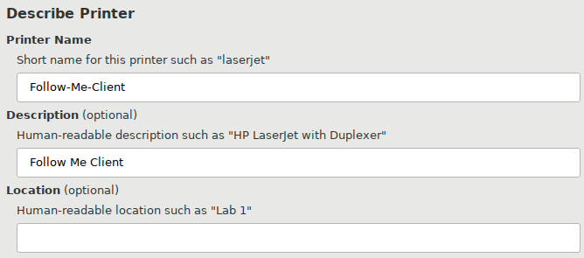

Step 5 - Testing
Log on as a user (a MEB user listed in the PaperCut NG/MF system) in your preferred Linux desktop GUI environment. Locate and execute the file /usr/local/papercut/client/pc-client-linux.sh. The PaperCut NG/MF client should open displaying the user's account balance.
It is usual to configure the client as a "Startup Program" or "AutoStart Program" launched during login. See your desktop documentation to see how to define a startup program.
When done create a script under /etc/profile.d/
# cat <<EOF >> pc-client-linux.sh
#!/bin/bash
if [ $(id -u) -gt 199 ] && [ "`id -gn`" = "`id -un`" ]; then
/usr/local/papercut/client/pc-client-linux.sh -m &
fi
EOF
# chmod 755 pc-client-linux.sh

