Instruction on how to add a Follow Me RICHO printer on MacOS

To be able to do the FollowMe installation you must use the local admin on the MacOS.

Download the PPD Installer
Open the Download folder and double click on the “Ricoh_IM_C3000_C3500_C4500_LIO_1.2.0.0.dmg” disk image file.

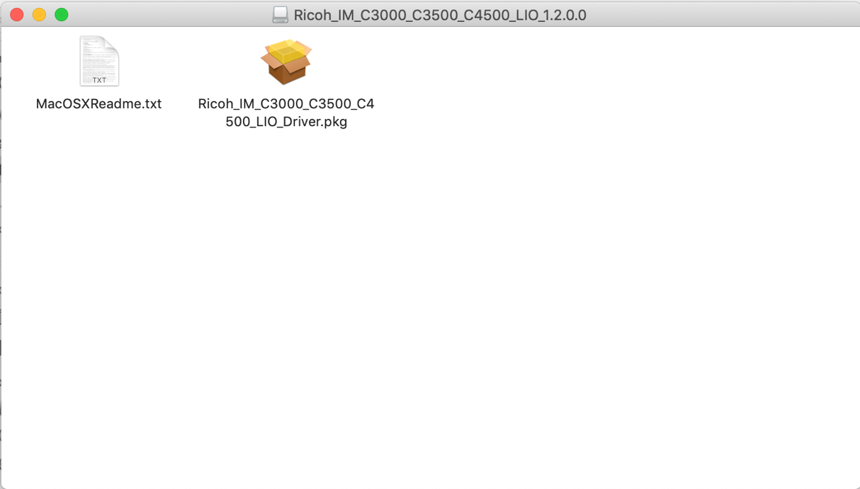

To run the installation package double click on the “pkg” icon

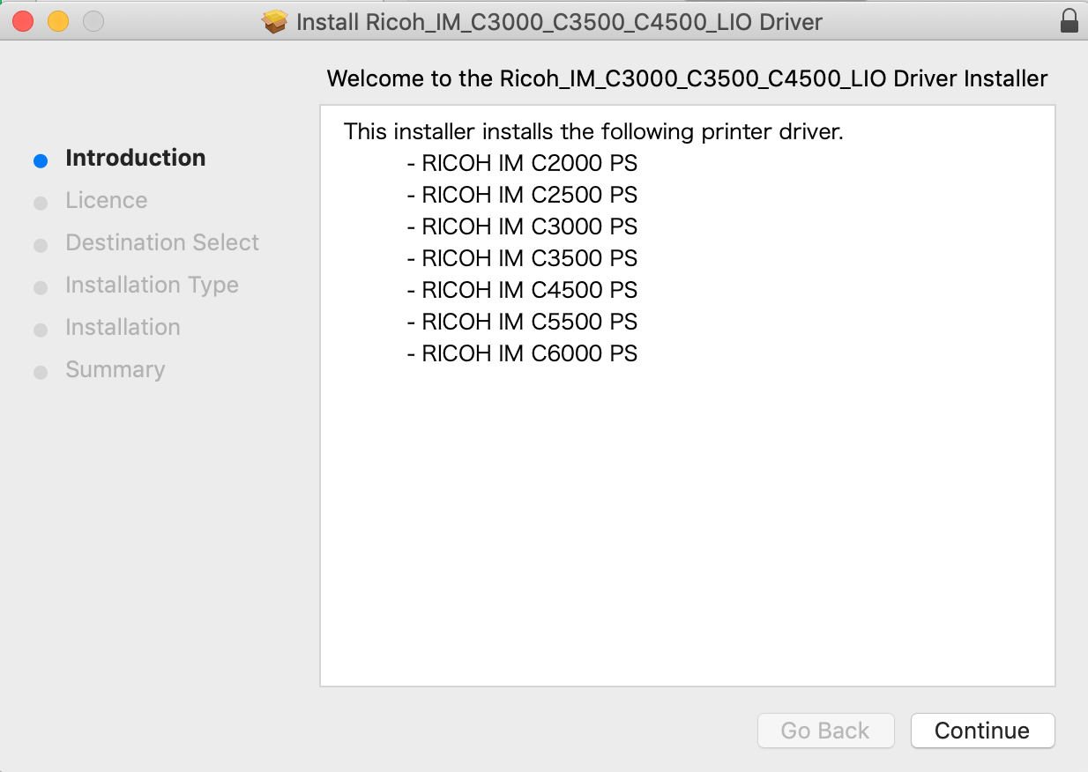
To finish the installation, press the “Continue” button.
Open the “System Preferences” under the Apple sign.
Select the “Printers & Scanners” and press the “+” sign to add a printer.
Open the Finder application

On the top of the screen press “Go”.
Connect to the server: meb-print01.meb.ki.se, type smb://meb-print01.meb.ki.se

Type your login credentials, MEB User name, and the AD password.

Double click on the text “PCClient”
Double click on the icon “mac” to open the folder.

Double click on the icon “client-local-install” to start the installation of the PaperCut application.

When the installation is done you must once again type the MEB login credentials.

Next open the System Preferences and click on the icon “Printers & Scanners”.

Press the “+” sign to add the Follow Me printer.

Click on the tab “IP” and type the Address “meb-print01.meb.ki.se”
Type “Follow Me Client” as a Queue: name and the same as Name:

Use: Select Software
And choose RICOHIM C5500PS

The last to do is to press the “Add” button..

Double click on the printer: “Follow Me Client” and press Settings and select the tab “Options”
Option Tray: “Lower Paper Trays”
Finisher: Finisher SR3270
PostScript: PostScript Emulation.

To have the PCClient to start automatically add the application, first open “System Preferences”

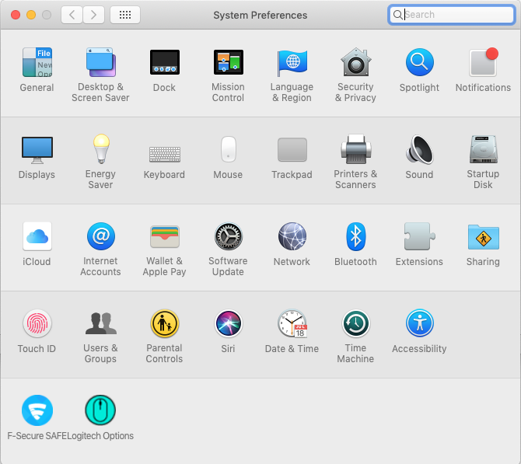
Select “Users & Groups” and select the tab “Login Items”.
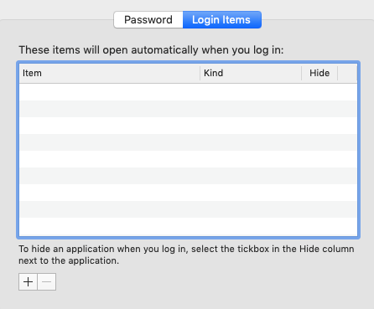
Press the “+” sign to add the application “PCClient” to start automatically.
