Installation guide – Horizon View Client outside MEB network
If you are outside MEB network you will find the VDI client here: http://svalin.meb.ki.se click the icon ”Install VMware Horizon View Client”.
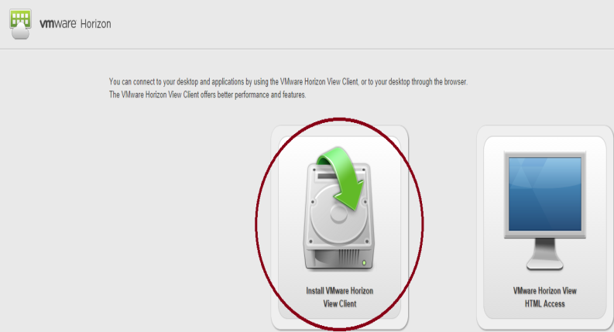
You will be forwarded to VMwares portal for downloading. You will find “VMware Horizon Client for Windows” and VMware Horizon Client for Mac and by clicking the ”Go to Downloads” on the client fitting for your device you will find the download page.
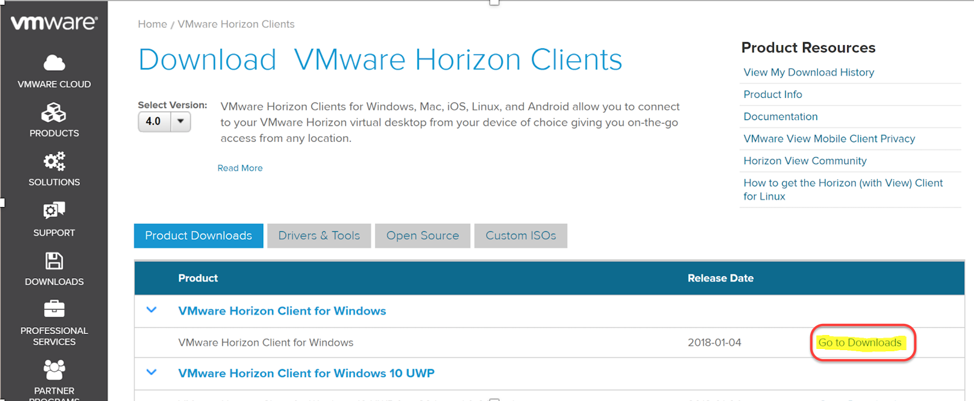
Press the ”Download” button to download the ”VMware Horizon Client For Windows”.
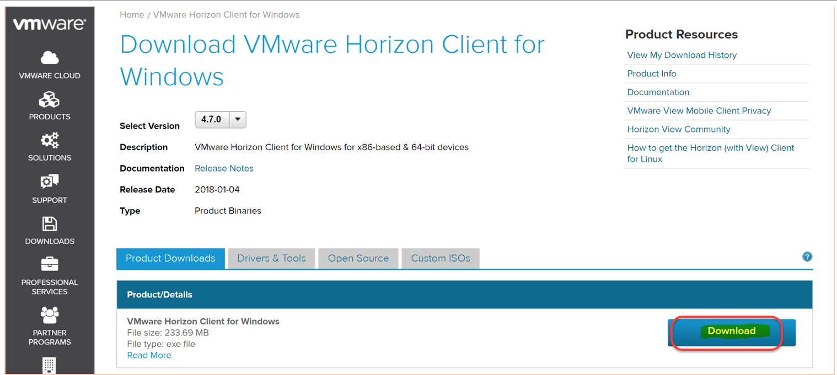
The download starts and when finished you will find a file like “VMware-Horizon-View-Client-xxxx” in your Downloads folder.
To install the horizon view client you need to be localadmin on your computer. If you do not have a localadmin account, it-support will help you, send an email to it-support@meb.ki.se.
Do shift+right click on the install file and chose ”Run as a different user” (your localadmin account) or ”Run as administrator” if your user account has admin rights on your computer.
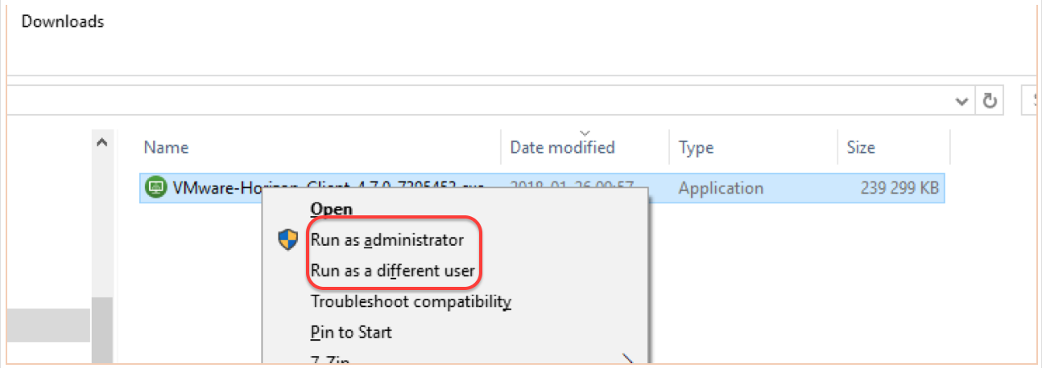
Enter your admin credential (username and password) and click ”OK”

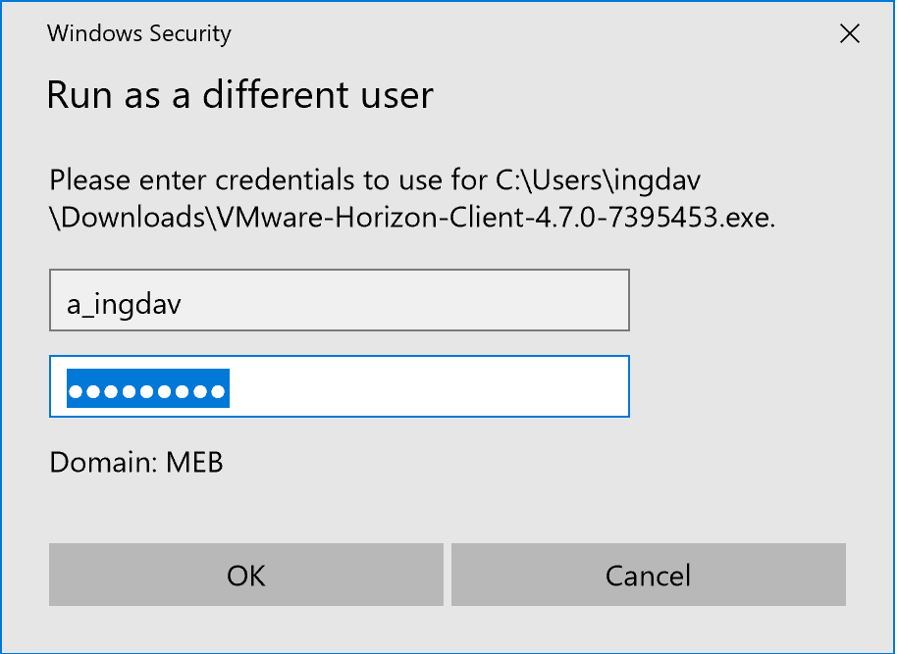
Click ”Agree & Install” follow the instruction on the screen.
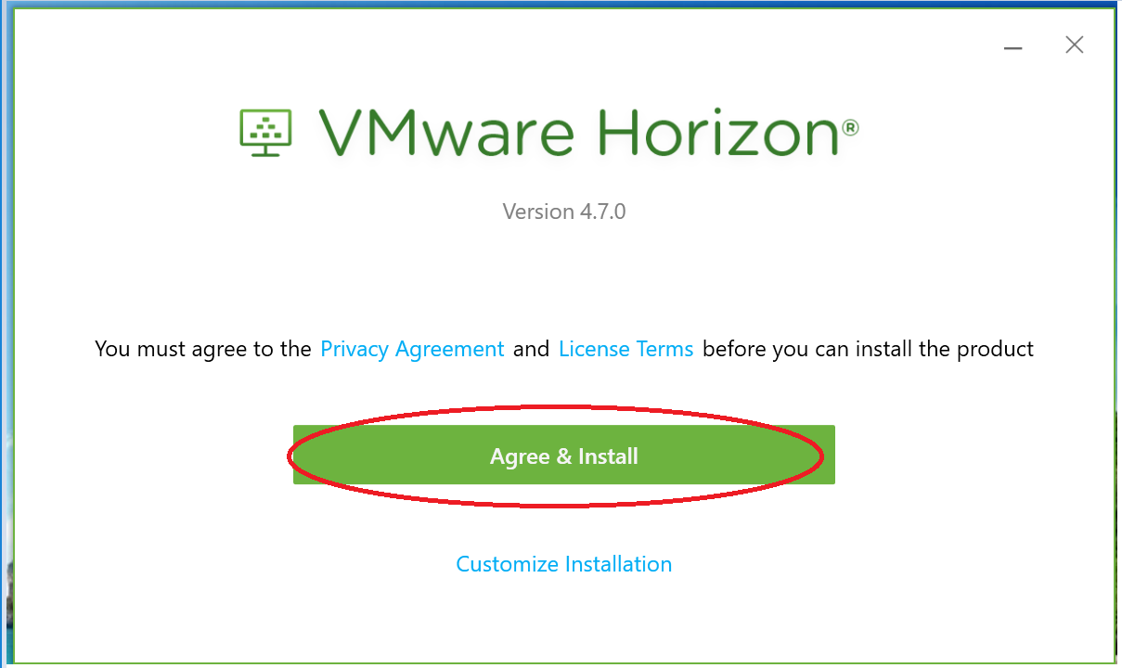
Click ”Finish”
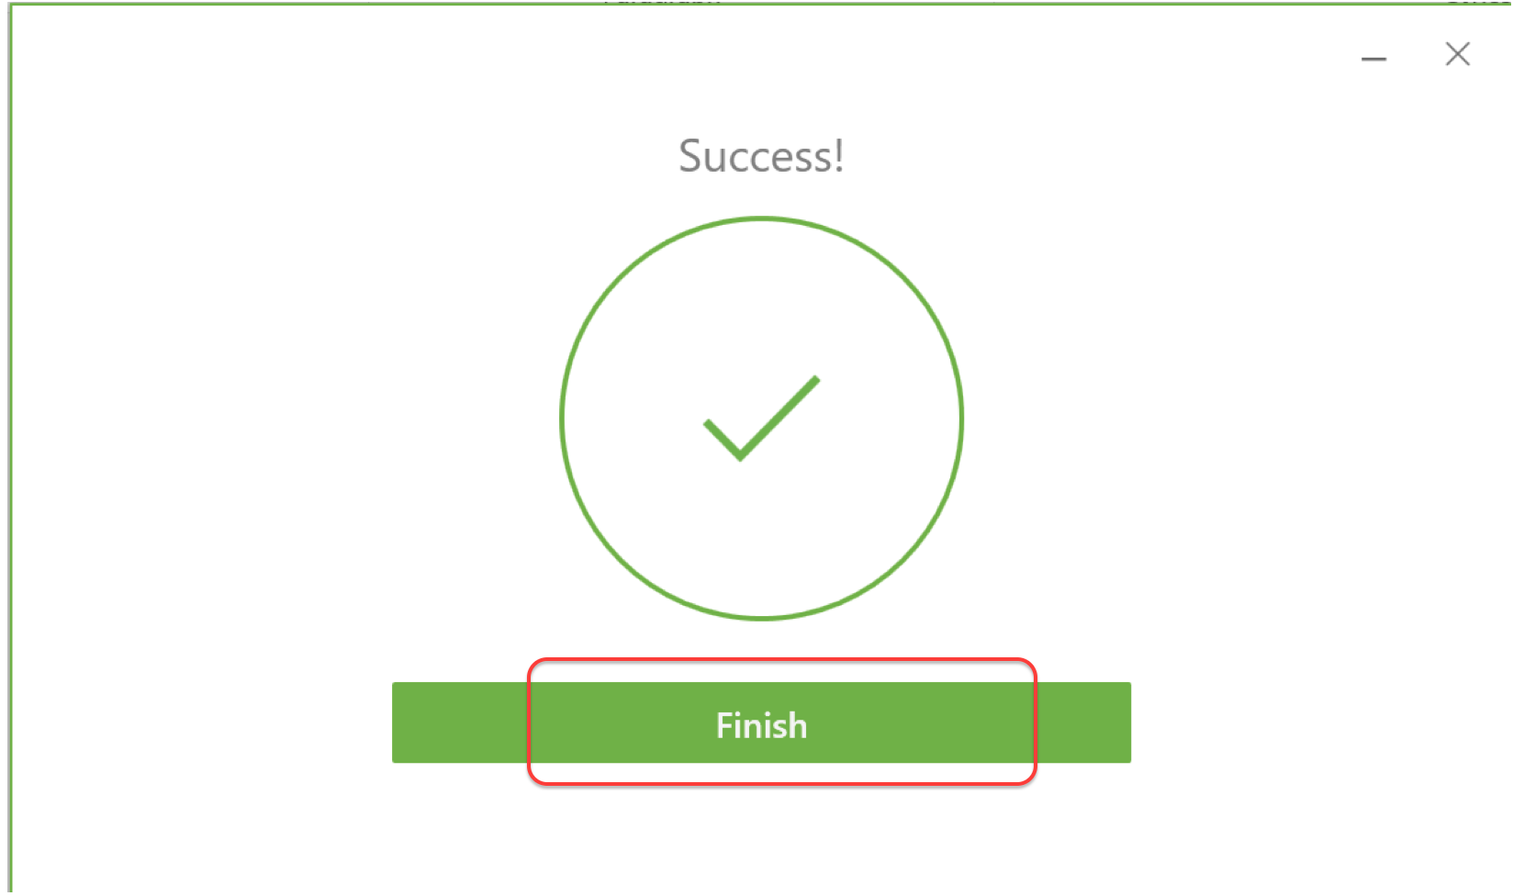
Restart your computer if you are prompted
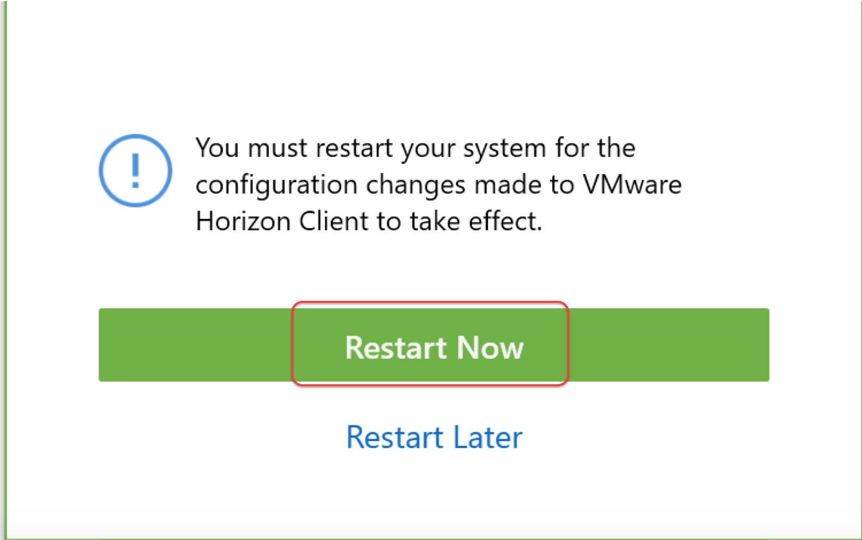

You will find the VDI client (VMware Horizon Client) as a shortcut on your desktop or else you will find it in the program menu. Dubble click the icon.
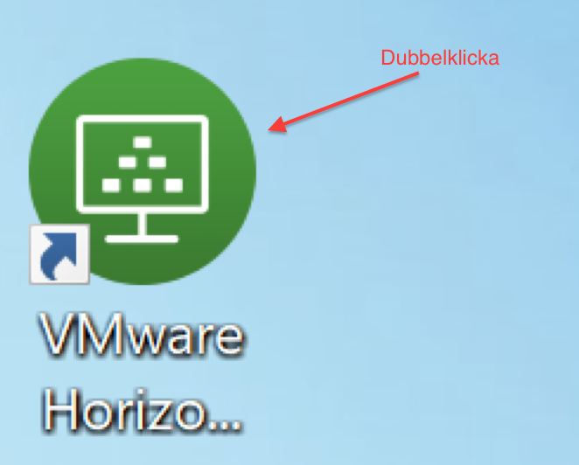
If you dont see a server on the opening page click ”+ New Server”

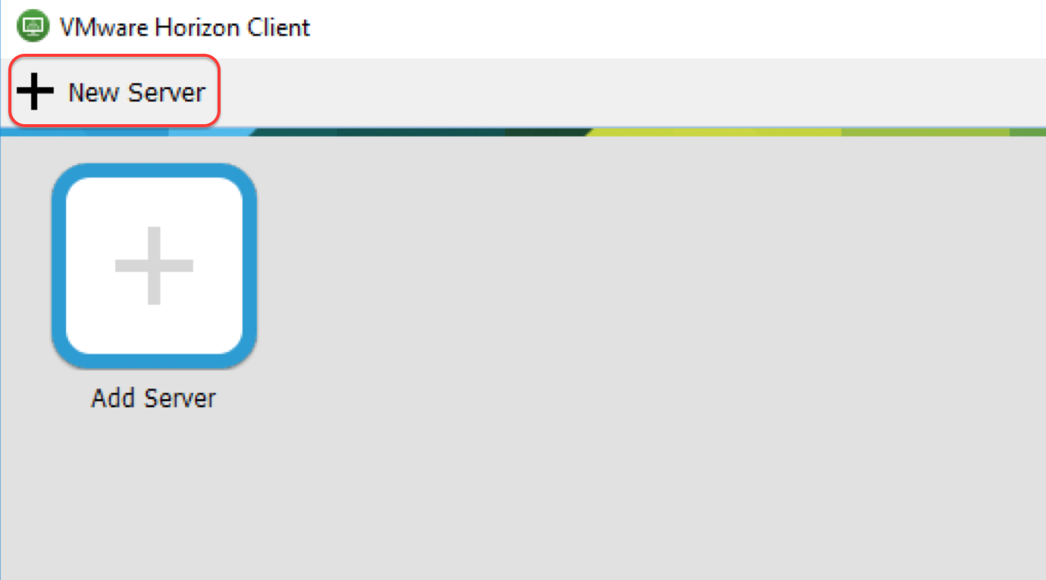
In the box that pops up enter the name of the VDI server: svalin.meb.ki.se and click ”Connect”
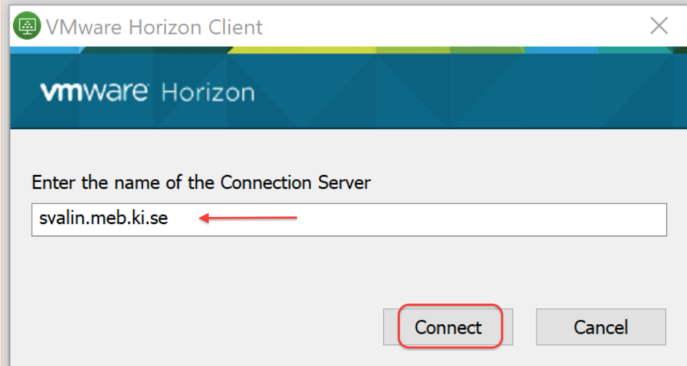
You will be prompted to enter your User name and Password which in this case is your MEB-ID, click ”Login”
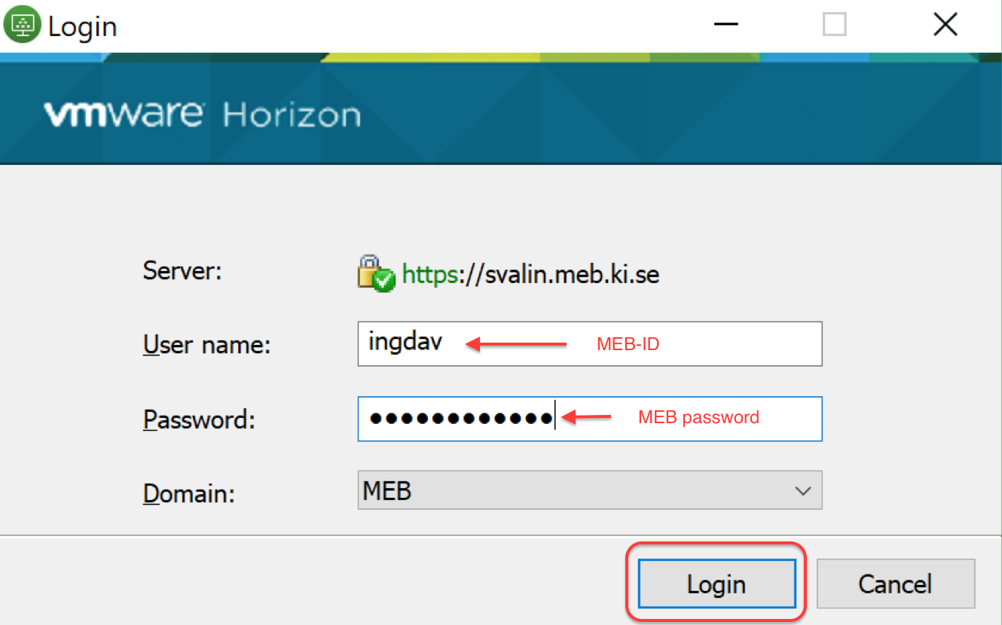
You will get a 6-digit code to the phone that you linked to your VDI-account at MEB. The code will arrive as a sms or in the i Mideye+ App, depending on what you have chosen. Enter the code and click ”Login”
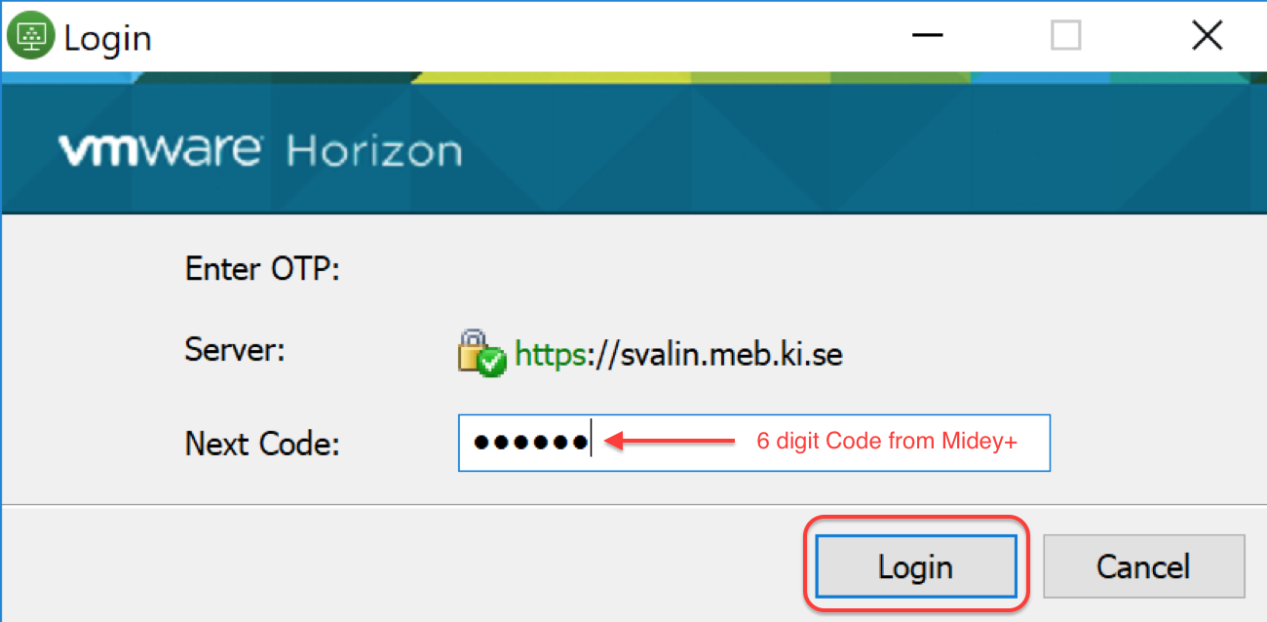

Right click on the Windows 10 button and choose PCoIP as default.
Now you are logged on to our VDI server and you can see your entitled ”poolen” . Double click the ”pool” and your VDI desktop will appear.
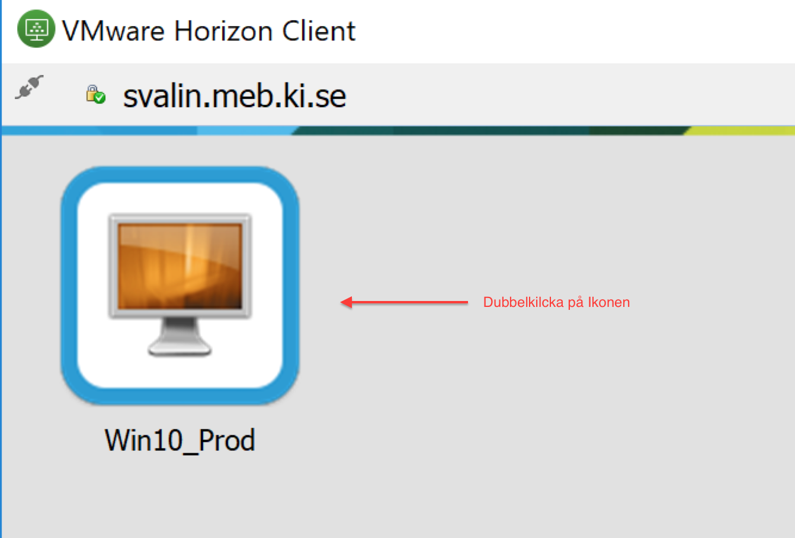
Different options on how to log off or disconnect from your VDI session:

To do a proper log off you can use the ”disconnect and log off” button from the ”options” menu in the Horizon Client. This is the same as if you do a ”shutdown” on your desktop computer. This will log you off the VDI desktop and the VDI server.
If you use the red cross on the horizon client your session just gets disconnected. Next time you log on the same session gets connected. This means that you can leave an application open/running and get back to it where you left off. If you for example start a SAS/STATA analysis in the VDI at MEB and do a disconnect you can log back in to the VDI from home and see how your analysis goes.
We always recommend you to do a “disconnect and log off” when you do not need to have anything ongoing.
You can have a session disconnected up to 3 days (without logging back in again) before you automatically will be signed out. This means that your application inside the VDI will be closed.

Make sure you always save your work (on P: or Z:) regularly when you are working in the VDI.
You get access to your Z: (home folder) on your second log in to your VDI account

When working in VDI you will find ”panel” in the upper part of the Horizon client where you can find the option button. To log off from your VDI session click the Option ”Disconnect and Log Off”

