Push ctrl and then klick RStudio you get this
Mac user push ctrl and command
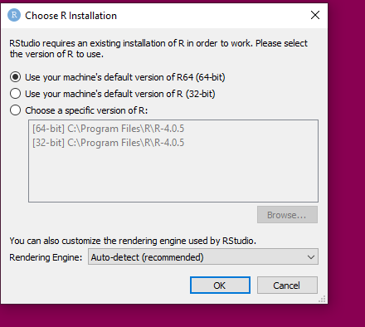

Change rendering engine to software

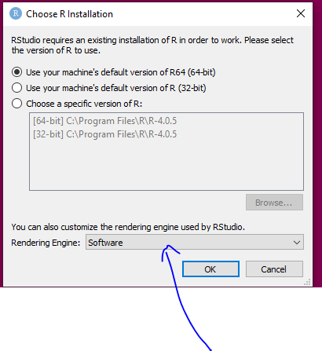
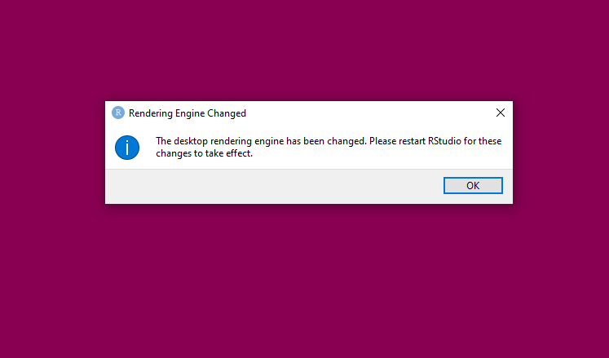
Klick again Rstudio now its working

