When your MEB-ID password has expired:
You log in with your old password
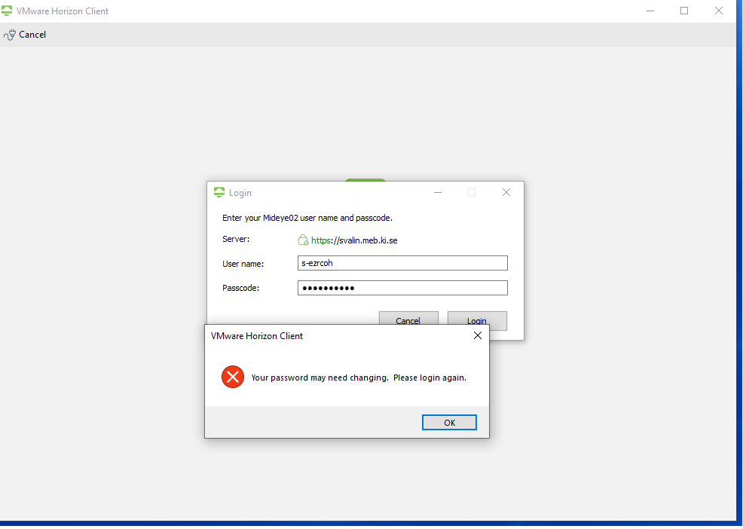
Click OK and write the old password again
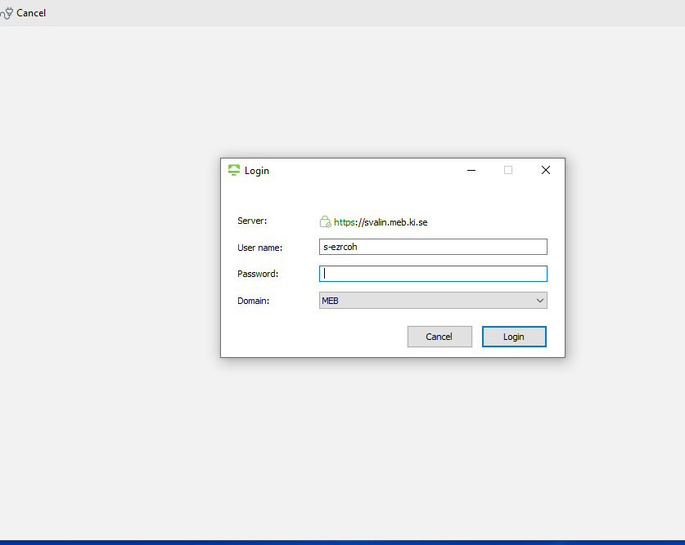
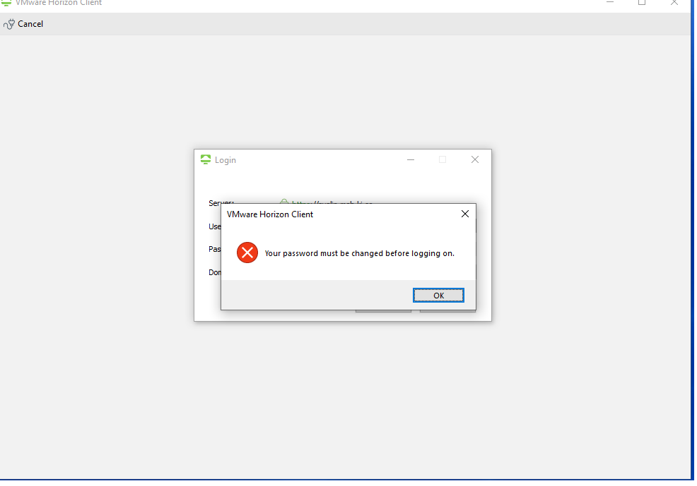
Click OK and change the password in the next prompt
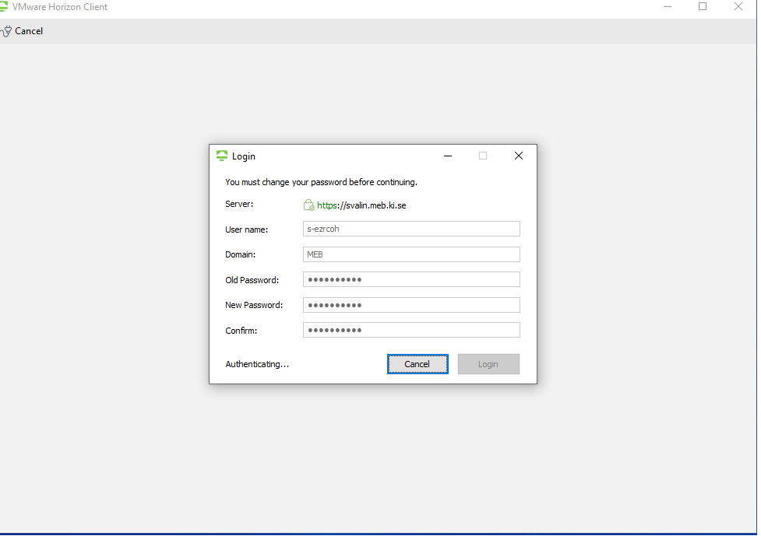
Now your new password is active in VDI.
If you have a MEB laptop that is not connected to the MEB network at the office when changing your MEB-ID password the old password will still be the password to log in to your laptop until you have connected it to the MEB network at the office next time.

